Experiment -10
NAME: A. VikranthReddy
Rg No:192424193
Course Code: DSA0406
Course Name: Fundamentals of Data Science for Data Processing
10. Scenario: You are working on a data visualization project and need to create basic plots using Matplotlib. You have a dataset containing the monthly sales data for a company, including the month and corresponding sales values. Your task is to develop a Python program that generates line plots and bar plots to visualize the sales data.
Question:
- How would you develop a Python program to create a line plot of the monthly sales data?
- 2: How would you develop a Python program to create a bar plot of the monthly sales data?
Code
1. Line Plot (Monthly Sales)
import matplotlib.pyplot as plt
months = ["Jan", "Feb", "Mar", "Apr", "May"]
sales = [12000, 15000, 17000, 16000, 18000]
plt.plot(months, sales)
plt.xlabel("Month")
plt.ylabel("Sales")
plt.title("Monthly Sales - Line Plot")
plt.show()
Output:
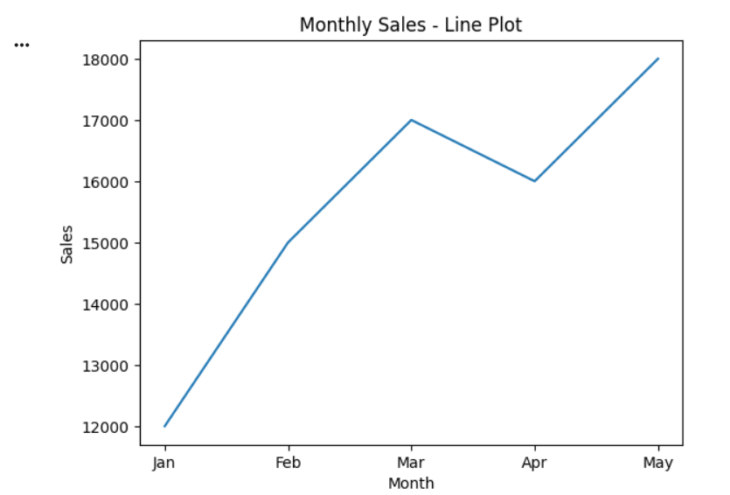
Code
2.Bar Plot (Monthly Sales)
import matplotlib.pyplot as plt
months = ["Jan", "Feb", "Mar", "Apr", "May"]
sales = [12000, 15000, 17000, 16000, 18000]
plt.bar(months, sales)
plt.xlabel("Month")
plt.ylabel("Sales")
plt.title("Monthly Sales - Bar Plot")
plt.show()
Output:

